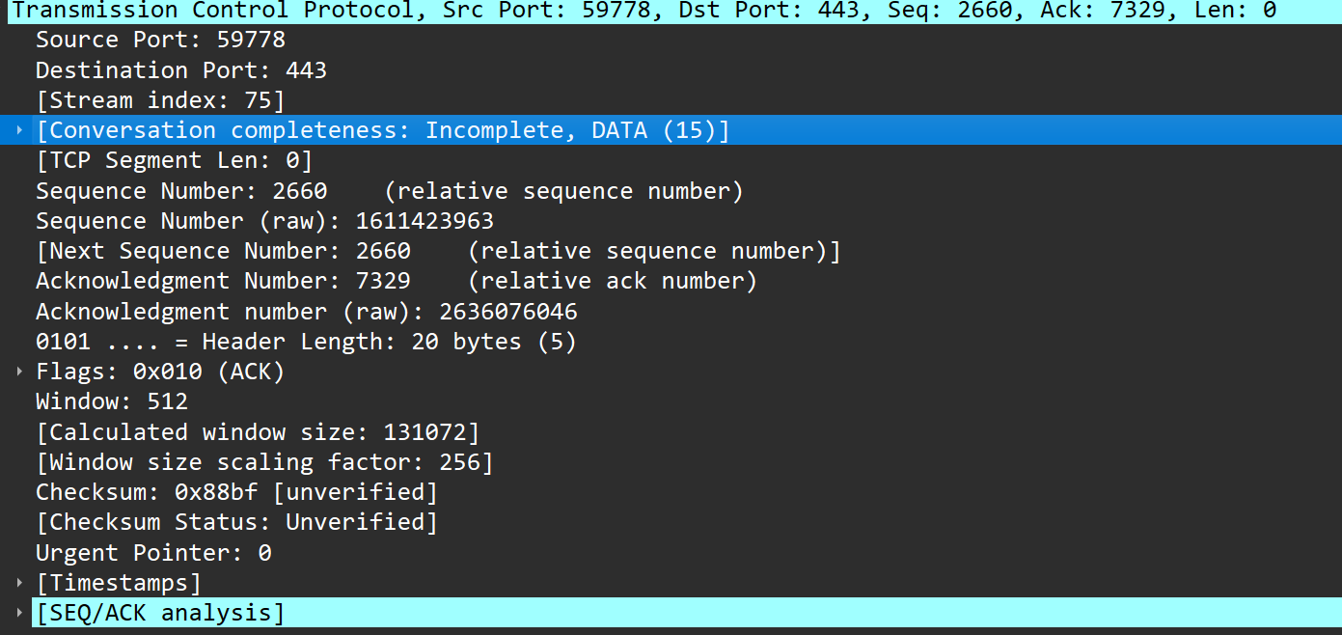
Fig:- TCP packet in Wireshark

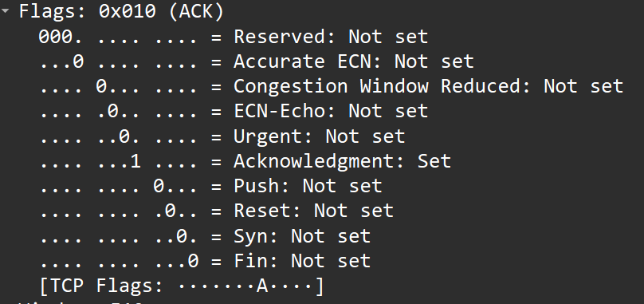
Fig:- Flags of same tcp packet

This is a tcp request send by my pc to my server.
→ We can examine that this TCP header is of size 20bytes. TCP header are usually of size 20-60 bytes.

→ Since, URG is not set, urgent pointer of 16 bits is not in TCP header.

→ Padding which is extra bits in multiple of 32 bits is not added. So, Padding is not present in header.

→ Checksum field of 16 bits is present in the header fields and this is used for error-checking as we have been discussing throughout the every wireshark analysis so far in previous files.

→ Window size of 16 bits specifies the size of the sender's receive window.
→ NOTED:- Here, the 16 bit unsigned integer is from 0 to 65535.hence, the port number 59778 in the source field is of 16 bits and same is true for other as well

